**What is SCCM?**

Microsoft System Center Configuration Manager (SCCM) is a Windows product that enables administrators to manage security and deployment of applications, devices that are part of an Enterprise. System Center is the family or suite of management tools from Microsoft. Organizations would rather purchase System Center Configuration Manager than purchasing a component in the System Center for updating or patching their systems.

**What is Configuration Manager?**

Microsoft Configuration Manager (part of Microsoft Intune and formerly SCCM) helps IT administrators manage large groups of Windows-based computers. It provides tools for software deployment, update management, OS deployment, inventory, compliance, and more.

**Hierarchies of sites**

* A *stand-alone primary site* is suitable for smaller deployments, and can be used to manage devices without having to install additional sites.
* A *secondary site* can only be installed as a child site below a primary site. This site type extends the reach of a primary site to manage devices in locations that have a slow network connection to the primary site. Even though a secondary site extends the primary site, the primary site manages all of the clients.
* The secondary site provides support for devices in the remote location. It provides support by compressing and then managing the transfer of information across your network that you send (deploy) to clients, and that clients send back to the site.

**Central Administration Site (CAS):**

**Used in large environments to centrally manage multiple primary sites. It doesn’t manage clients directly but provides centralized reporting and configuration.**

**Primary Site:**

**Manages clients directly and contains its own database. Can work alone (stand-alone) or as a child under a CAS in larger hierarchies.**

**Stand-alone Primary Site:**

**Suitable for small to medium deployments. It manages clients independently but can be expanded later by adding a CAS.**

**Secondary Site:**

**Installed under a primary site to support remote locations with slow network links. It doesn’t manage clients but helps with content distribution and data transfer.**

**The following diagrams show some example site designs.**

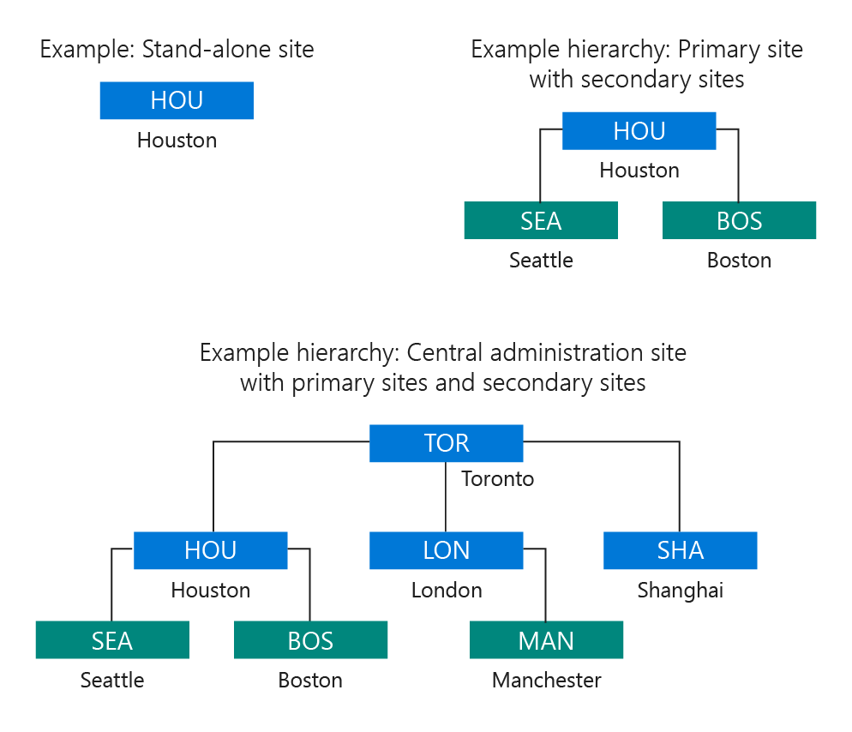

**Site system servers and site system rolesEach Configuration Manager site installs site system roles that support management operations. The following roles are installed by default when you install a site:**

* **The site server role is assigned to the computer where you install the site.**
* **The site database server role is assigned to the SQL Server that hosts the site database.**